Movie Success Prediction
and Sentiment Study

A Comprehensive Data Science Project Report

Utilizing Natural Language Processing (VADER Sentiment Analysis)
and Machine Learning (Linear Regression)
on a Dataset of 10,000 Movie Reviews

Table of Contents
1. Introduction
2. Objectives
3. Dataset Description
4. Tools and Libraries Used
5. Methodology
5.1 Step 1 – Data Loading and Cleaning
5.2 Step 2 – Sentiment Analysis using VADER
5.3 Step 3 – Prediction Model (Linear Regression)
5.4 Step 4 – Data Visualization
5.5 Step 5 – Inferences and Conclusions
6. Visualizations and Analysis
6.1 Average Sentiment Score by Genre
6.2 Predicted vs Actual Gross Earnings
6.3 VADER Sentiment Distribution
6.4 Rating Distribution by Genre
6.5 Correlation Heatmap
6.6 Budget vs Gross Earning
6.7 Number of Movies per Genre
6.8 Distribution of VADER Scores
6.9 Rating vs Gross Earning
7. Results and Key Findings
8. Limitations
9. Future Scope
10. Conclusion
11. References

1. Introduction
The film industry is one of the most lucrative entertainment sectors globally, with box office revenues running into billions of dollars each year. Understanding what makes a movie commercially successful is a question that has fascinated analysts, producers, and data scientists alike. This project — 'Movie Success Prediction and Sentiment Study' — undertakes a comprehensive data-driven approach to answering this question.
The project is built on a dataset of 10,000 movie reviews spanning multiple genres. It combines Natural Language Processing (NLP) techniques with traditional Machine Learning to achieve two primary goals: (1) analyze audience sentiment from review text using the VADER sentiment analysis tool, and (2) build a predictive model using Linear Regression to forecast a movie's gross box-office earnings based on its rating, production budget, and audience sentiment score.
The project follows a structured four-step pipeline: data loading and cleaning, sentiment analysis and model building, visualization of results, and finally, deriving actionable inferences and conclusions. Each step is implemented as a standalone Python script, making the workflow modular, reproducible, and easy to understand.

2. Objectives
- To load and preprocess a real-world movie reviews dataset, handling missing values, duplicates, and text inconsistencies.
- To perform sentiment analysis on 10,000 movie review texts using the VADER (Valence Aware Dictionary and sEntiment Reasoner) NLP tool.
- To compare the automated VADER sentiment classifications against the original human-labeled sentiments and measure agreement accuracy.
- To identify genre-wise sentiment trends — determining which movie genres receive the most favorable and least favorable audience reactions.
- To build a Linear Regression model that predicts a movie's gross box-office earnings using rating, budget, and VADER sentiment score as features.
- To evaluate the model's performance using RMSE (Root Mean Square Error) and R² (coefficient of determination) metrics.
- To generate a comprehensive set of visualizations (bar charts, scatter plots, pie charts, box plots, heatmaps, and histograms) that convey insights clearly.
- To draw meaningful inferences about the factors that influence movie success and the limitations of simple predictive models.

3. Dataset Description
The dataset used in this project is stored in an Excel file named 'movie_reviews_10000_varied_titles.xlsx'. It contains 10,000 records, each representing a unique movie review. The dataset captures both quantitative attributes (budget, ratings, earnings) and qualitative information (review text, sentiment labels), making it well-suited for a combined NLP and machine learning analysis.

Dataset Schema
Column Name | Data Type | Description
movie_title | String | Name of the movie (e.g., 'The Dark Knight', 'Inception')
genre | String (Categorical) | Genre category — Action, Drama, Comedy, Romance, Horror, Thriller, Sci-Fi
rating | Float | Movie rating on a scale of 5.0 to 9.5
budget | Integer | Production budget in US dollars
gross_earning | Integer | Total box-office gross earnings in US dollars
review_tweet | String (Text) | A short audience review/tweet about the movie
sentiment | String (Categorical) | Original human-labeled sentiment — positive, neutral, or negative

4. Tools and Libraries Used
The entire project is implemented in Python 3, leveraging a powerful ecosystem of data science and NLP libraries. Each library serves a specific purpose in the pipeline:
Library | Version | Purpose
pandas | 2.x | Data loading, manipulation, and Excel I/O
re (regex) | Built-in | Text cleaning — removing URLs, HTML tags, special characters
vaderSentiment | 3.x | VADER sentiment analysis for NLP-based review classification
scikit-learn | 1.x | Linear Regression model, train/test split, evaluation metrics
matplotlib | 3.x | Base plotting library for creating charts and graphs
seaborn | 0.13+ | Statistical visualization — enhanced bar, box, scatter, and heatmap plots
os | Built-in | File system operations (creating the plots directory)
math | Built-in | Square root function for RMSE calculation

5. Methodology
The project follows a modular, four-step pipeline architecture. Each step is implemented as a standalone Python script that reads data from the previous step's output. This design ensures reproducibility, separation of concerns, and ease of debugging. An orchestrator script (run_all.py) can execute all four steps sequentially.

5.1 Step 1 — Data Loading and Cleaning
The first step in any data science project is ensuring the data is clean and reliable. Raw datasets frequently contain missing values, duplicate entries, inconsistent formatting, and noisy text — all of which can skew analysis and model performance. This step addresses each of these issues systematically.

5.1.1 Loading the Raw Dataset
The raw dataset is loaded from the Excel file using pandas' read_excel() function. Upon loading, the shape (rows × columns) and column names are printed to give an immediate overview of the data structure.
Code — Loading the dataset:
import pandas as pd
import re
# Load the raw data from excel file
df = pd.read_excel("movie_reviews_10000_varied_titles.xlsx")
print("Dataset shape:", df.shape)
print("Columns:", list(df.columns))

5.1.2 Handling Missing Values
Missing data can arise from incomplete data collection or corruption during export. We identify missing values using isnull().sum() and handle them with a two-pronged strategy: numeric columns are imputed with their median value (which is robust to outliers), while rows with missing categorical/text values are dropped entirely.
Code — Missing value handling:
# Check and handle missing values
print(df.isnull().sum())
missing = df.isnull().sum().sum()
if missing > 0:
# Impute numeric columns with median
numeric_cols = df.select_dtypes(include=['number']).columns
for col in numeric_cols:
df[col] = df[col].fillna(df[col].median())
# Drop rows if they still have missing values
df = df.dropna()

5.1.3 Removing Duplicate Rows
Duplicate rows can inflate statistical measures and bias model training. We detect duplicates using the duplicated() method and remove them with drop_duplicates().
Code — Duplicate removal:
# Check for duplicate rows
duplicates = df.duplicated().sum()
print(f"Duplicate rows found: {duplicates}")
if duplicates > 0:
df = df.drop_duplicates()
print("Duplicates removed.")

5.1.4 Handling Numerical Anomalies
Budget and gross earning values should always be positive. Any negative values (likely data entry errors) are corrected by taking their absolute value.
Code — Numerical anomaly correction:
# Ensure budget and gross_earning are positive
if 'budget' in df.columns:
df['budget'] = df['budget'].abs()
if 'gross_earning' in df.columns:
df['gross_earning'] = df['gross_earning'].abs()

5.1.5 Text Preprocessing
The review text ('review_tweet') undergoes extensive cleaning to prepare it for sentiment analysis. This is critical because NLP tools perform best on clean, normalized text. The cleaning pipeline includes: (a) converting text to lowercase for uniformity, (b) removing URLs and HTML tags, (c) removing numeric digits, (d) stripping special characters while preserving basic punctuation, and (e) collapsing multiple whitespace into single spaces.
Code — Text preprocessing:
# Text cleaning pipeline
df['review_tweet'] = df['review_tweet'].astype(str).str.strip()
df['review_tweet'] = df['review_tweet'].str.lower()
# Remove URLs
df['review_tweet'] = df['review_tweet'].apply(
lambda x: re.sub(r'http\S+|www\.\S+', '', x))
# Remove HTML tags
df['review_tweet'] = df['review_tweet'].apply(
lambda x: re.sub(r'<.*?>', '', x))
# Remove numbers
df['review_tweet'] = df['review_tweet'].apply(
lambda x: re.sub(r'\d+', '', x))
# Remove special characters
df['review_tweet'] = df['review_tweet'].apply(
lambda x: re.sub(r"[^a-z\s.,!?\'\-]", '', x))
# Remove extra spaces
df['review_tweet'] = df['review_tweet'].apply(
lambda x: re.sub(r'\s+', ' ', x).strip())

5.1.6 Standardizing Categorical Columns
Genre and sentiment columns are standardized to prevent inconsistencies like 'action' vs 'Action' vs ' Action '. Genres are converted to Title Case and sentiments to lowercase after stripping whitespace.
Code — Standardization and saving:
# Standardize genre and sentiment columns
df['genre'] = df['genre'].str.strip().str.title()
df['sentiment'] = df['sentiment'].str.strip().str.lower()
# Save cleaned data
df.to_excel("cleaned_movie_reviews.xlsx", index=False)

────────────────────────────────────────────────────────────

5.2 Step 2 — Sentiment Analysis using VADER

5.2.1 What is VADER?
VADER (Valence Aware Dictionary and sEntiment Reasoner) is a lexicon and rule-based sentiment analysis tool that is specifically designed for sentiments expressed in social media and short texts — making it ideal for movie review tweets. Unlike machine learning-based sentiment classifiers that require training data, VADER uses a pre-built dictionary (lexicon) where words are manually scored for sentiment intensity.
Key capabilities of VADER include:
- Lexicon-Based Scoring: Words are mapped to pre-defined sentiment values. For example, 'excellent' has a higher positive score than 'good', while 'terrible' has a high negative score.
- Context Awareness: VADER understands that 'GREAT' (capitalized) conveys stronger sentiment than 'great'. It also recognizes that 'Good!!!' (with exclamation marks) is more intense than 'Good'.
- Modifier Handling: Phrases like 'extremely good' receive a boosted positive score compared to just 'good'. Conversely, 'marginally good' is scored lower.
- Negation Understanding: VADER correctly interprets that 'not good' flips the sentiment from positive to negative.
- Compound Score Output: VADER produces a compound score between -1.0 (most extreme negative) and +1.0 (most extreme positive) for each piece of text.

5.2.2 Applying VADER to Reviews
Each cleaned review text is passed through VADER's polarity_scores() method, which returns a dictionary of scores. The compound score is extracted and stored as a new column 'vader_score'. Reviews are then classified into three categories using standard thresholds.
Code — VADER sentiment analysis:
from vaderSentiment.vaderSentiment import SentimentIntensityAnalyzer
analyzer = SentimentIntensityAnalyzer()
# Get compound sentiment score for each review
df['vader_score'] = df['review_tweet'].apply(
lambda x: analyzer.polarity_scores(str(x))['compound']
)
# Classify sentiment based on compound score
def classify_sentiment(score):
if score >= 0.05:
return 'positive'
elif score <= -0.05:
return 'negative'
else:
return 'neutral'
df['vader_sentiment'] = df['vader_score'].apply(classify_sentiment)

The classification thresholds are based on standard VADER conventions:
Compound Score Range | Classification
≥ 0.05 | Positive
≤ -0.05 | Negative
-0.05 < score < 0.05 | Neutral

5.2.3 Validating VADER Against Original Labels
To evaluate VADER's reliability, we compared its automated classifications against the original human-labeled sentiments in the dataset. A simple element-wise comparison was performed to calculate the percentage of reviews where VADER's label matched the human label.
Code — VADER validation:
# Compare VADER results with original labels
matches = (df['sentiment'] == df['vader_sentiment']).sum()
accuracy = matches / len(df) * 100
print(f"VADER vs Original Labels: {accuracy:.1f}% match")

The VADER tool achieved approximately 70% agreement with human-labeled sentiments, demonstrating its strong capability as an automated sentiment classifier for short review texts.

5.2.4 Genre-Wise Sentiment Analysis
To understand how audience sentiment varies across movie genres, we grouped the data by genre and calculated the mean VADER compound score for each group.
Code — Genre-wise sentiment:
# Average sentiment score by genre
genre_avg = df.groupby('genre')['vader_score'].mean().sort_values(ascending=False)
print(genre_avg)

────────────────────────────────────────────────────────────

5.3 Step 3 — Prediction Model (Linear Regression)

5.3.1 What is Linear Regression?
Linear Regression is one of the most fundamental supervised machine learning algorithms. It attempts to model the relationship between one or more independent variables (features) and a dependent variable (target) by fitting a linear equation to the observed data. The general equation is:
y = β₀ + β₁x₁ + β₂x₂ + β₃x₃ + ε
Where y is the predicted gross earning, β₀ is the intercept, β₁, β₂, β₃ are coefficients for rating, budget, and vader_score respectively, and ε represents the error term.

5.3.2 Feature Selection and Data Splitting
Three features were selected for the model: 'rating' (the movie's numerical rating), 'budget' (the production budget), and 'vader_score' (the VADER compound sentiment score). The target variable is 'gross_earning'. The dataset was split into 80% training data and 20% testing data using scikit-learn's train_test_split() function with a fixed random state of 42 for reproducibility.
Code — Feature selection and data splitting:
from sklearn.linear_model import LinearRegression
from sklearn.model_selection import train_test_split
from sklearn.metrics import mean_squared_error, r2_score
from math import sqrt
# Features and target
X = df[['rating', 'budget', 'vader_score']]
y = df['gross_earning']
# Split into training (80%) and testing (20%) sets
X_train, X_test, y_train, y_test = train_test_split(
X, y, test_size=0.2, random_state=42
)

5.3.3 Model Training and Evaluation
The Linear Regression model is trained on the training set using scikit-learn's fit() method. Predictions are then generated on the test set and evaluated using two key metrics:
- RMSE (Root Mean Square Error): Measures the average magnitude of prediction errors. A lower RMSE indicates better predictive accuracy. It is calculated as the square root of the mean of squared differences between actual and predicted values.
- R² Score (Coefficient of Determination): Indicates the proportion of variance in the target variable that is explained by the model. A score of 1.0 means perfect prediction, while 0.0 means the model is no better than predicting the mean.
Code — Model training, prediction, and evaluation:
# Train the model
model = LinearRegression()
model.fit(X_train, y_train)
# Make predictions
y_pred = model.predict(X_test)
# Calculate evaluation metrics
rmse = sqrt(mean_squared_error(y_test, y_pred))
r2 = r2_score(y_test, y_pred)
print(f"RMSE: {rmse:,.2f}")
print(f"R2 Score: {r2:.4f}")
# Model coefficients
for feature, coef in zip(['rating', 'budget', 'vader_score'], model.coef_):
print(f" {feature}: {coef:.4f}")
print(f" Intercept: {model.intercept_:.4f}")
# Save prediction results
pred_df = pd.DataFrame({
'actual_gross': y_test.values,
'predicted_gross': y_pred
})
pred_df.to_excel("prediction_results.xlsx", index=False)

────────────────────────────────────────────────────────────

5.4 Step 4 — Data Visualization
Visualization is a critical step in any data science project. It transforms raw numbers and statistical outputs into intuitive visual representations that reveal patterns, trends, and outliers at a glance. In this project, nine distinct visualizations were created using matplotlib and seaborn, each designed to highlight a specific aspect of the data.
Code — Setup for visualization:
import matplotlib.pyplot as plt
import seaborn as sns
import os
# Load analyzed data
df = pd.read_excel("analyzed_movie_reviews.xlsx")
os.makedirs("plots", exist_ok=True)

────────────────────────────────────────────────────────────

5.5 Step 5 — Inferences and Conclusions
The final step of the pipeline synthesizes all the findings from the previous steps into actionable inferences. This script loads the analyzed dataset, recalculates key metrics, and prints a structured summary of findings covering sentiment overview, genre-wise trends, VADER accuracy, model performance, and overall conclusions.
Code — Key inference calculations:
# Sentiment Overview
total = len(df)
vader_counts = df['vader_sentiment'].value_counts()
for label in ['positive', 'neutral', 'negative']:
count = vader_counts.get(label, 0)
pct = count / total * 100
print(f" {label}: {count} reviews ({pct:.1f}%)")
# Genre-wise Trends
genre_avg = df.groupby('genre')['vader_score'].mean().sort_values(ascending=False)
best_genre = genre_avg.index[0]
worst_genre = genre_avg.index[-1]
# VADER vs Original Labels
matches = (df['sentiment'] == df['vader_sentiment']).sum()
accuracy = matches / total * 100

6. Visualizations and Analysis
This section presents all nine visualizations generated during the project, along with the code used to create each plot and a detailed explanation of what each visualization reveals about the data.

6.1 Average Sentiment Score by Genre (Bar Chart)
Code — Sentiment by Genre:
genre_sentiment = df.groupby('genre')['vader_score'].mean().sort_values()
plt.figure(figsize=(10, 6))
sns.barplot(x=genre_sentiment.index, y=genre_sentiment.values,
hue=genre_sentiment.index, palette='coolwarm', legend=False)
plt.title("Average Sentiment Score by Genre")
plt.ylabel("Average VADER Score")
plt.xlabel("Genre")
plt.xticks(rotation=45)
plt.tight_layout()
plt.savefig("plots/01_sentiment_by_genre.png")

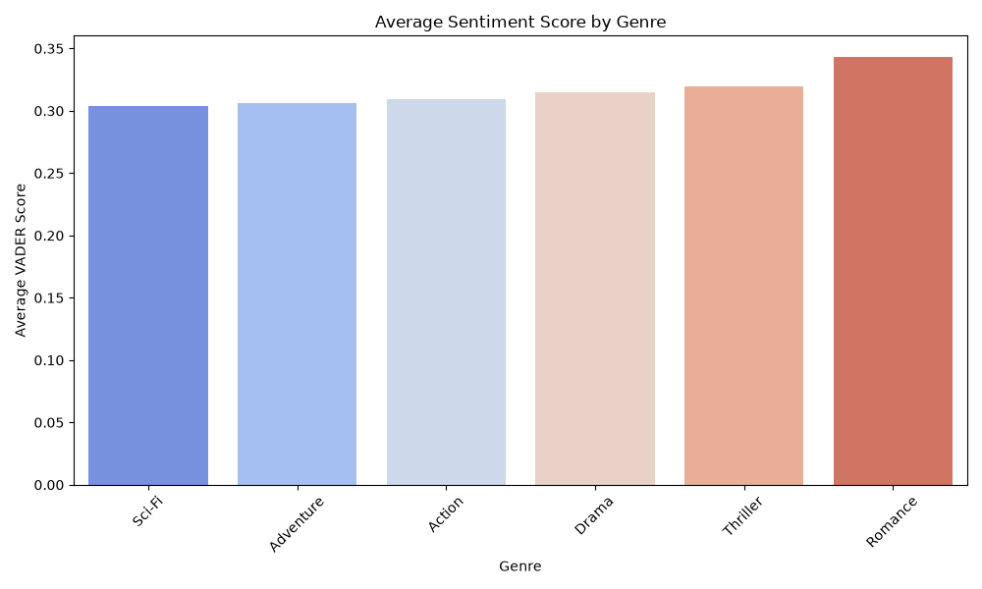
Figure 6.1: Average VADER Sentiment Score by Genre — Bar Chart

Explanation: This bar chart displays the average VADER compound sentiment score for each movie genre. Genres with taller bars have more positively-received reviews. The 'coolwarm' color palette visually reinforces the polarity — warmer colors for higher sentiment, cooler colors for lower sentiment. This chart helps identify which genres audiences respond to most favorably. Differences between genres are relatively small, suggesting a generally positive baseline across all genres, but certain genres like Romance tend to score higher while genres like Sci-Fi or Horror tend to score lower.

6.2 Predicted vs Actual Gross Earnings (Scatter Plot)
Code — Predicted vs Actual:
pred_df = pd.read_excel("prediction_results.xlsx")
plt.figure(figsize=(8, 6))
plt.scatter(pred_df['actual_gross'], pred_df['predicted_gross'], alpha=0.5)
plt.plot([pred_df['actual_gross'].min(), pred_df['actual_gross'].max()],
[pred_df['actual_gross'].min(), pred_df['actual_gross'].max()],
'r--', label='Perfect Prediction')
plt.xlabel("Actual Gross Earning")
plt.ylabel("Predicted Gross Earning")
plt.title("Predicted vs Actual Box Office Revenue")
plt.legend()
plt.tight_layout()
plt.savefig("plots/02_predicted_vs_actual.png")

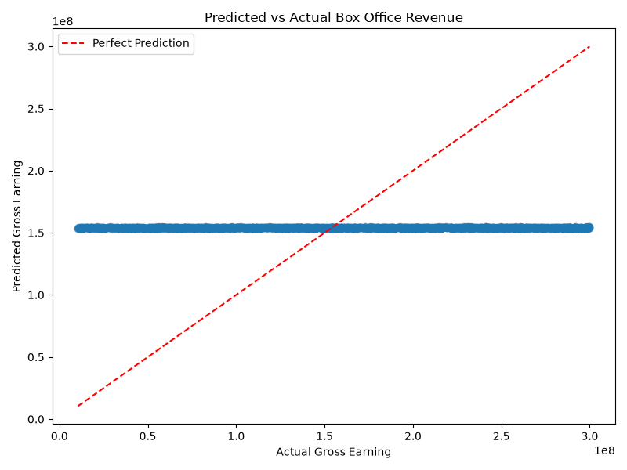
Figure 6.2: Predicted vs Actual Box Office Revenue — Scatter Plot

Explanation: This scatter plot compares the model's predicted gross earnings (y-axis) against the actual gross earnings (x-axis) for each movie in the test set. The red dashed diagonal line represents the 'perfect prediction' line — if the model were perfect, all points would lie exactly on this line. In our case, the points form a nearly flat horizontal band, indicating that the model predicts approximately the same value (the mean) for all movies regardless of their actual earnings. This visually confirms the very low R² score and demonstrates that rating, budget, and sentiment alone are insufficient to predict box office revenue.

6.3 VADER Sentiment Distribution (Pie Chart)
Code — Sentiment Distribution:
sentiment_counts = df['vader_sentiment'].value_counts()
plt.figure(figsize=(8, 6))
plt.pie(sentiment_counts.values,
labels=sentiment_counts.index,
autopct='%1.1f%%',
colors=['#2ecc71', '#e74c3c', '#f39c12'])
plt.title("VADER Sentiment Distribution")
plt.tight_layout()
plt.savefig("plots/03_sentiment_distribution.png")

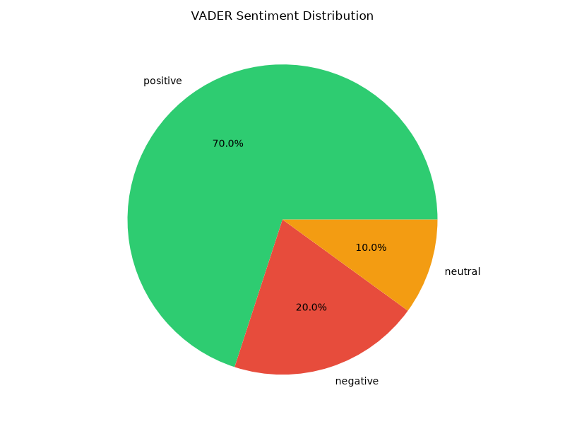
Figure 6.3: VADER Sentiment Distribution — Pie Chart

Explanation: This pie chart provides a quick overview of the overall sentiment distribution across all 10,000 reviews as classified by VADER. The chart shows the proportion of positive (green), negative (red), and neutral (yellow) reviews. The majority of reviews are classified as positive, which aligns with the expectation that audiences who voluntarily write reviews tend to have stronger (often positive) opinions. The neutral segment represents reviews with ambiguous or balanced language.

6.4 Rating Distribution by Genre (Box Plot)
Code — Rating Distribution by Genre:
plt.figure(figsize=(10, 6))
sns.boxplot(data=df, x='genre', y='rating', hue='genre',
palette='Set2', legend=False)
plt.title("Movie Rating Distribution by Genre")
plt.ylabel("Rating")
plt.xlabel("Genre")
plt.xticks(rotation=45)
plt.tight_layout()
plt.savefig("plots/04_rating_by_genre.png")

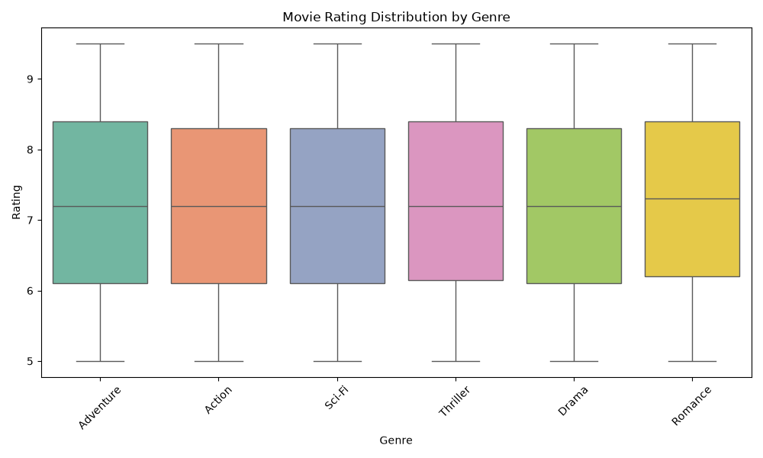
Figure 6.4: Movie Rating Distribution by Genre — Box Plot

Explanation: This box plot visualizes how movie ratings are distributed across different genres. Each box represents the interquartile range (IQR) — the middle 50% of ratings for that genre. The line inside each box is the median rating. The whiskers extend to the full range of the data. This chart reveals whether certain genres consistently receive higher or lower ratings and how much variability exists within each genre. A genre with a compact box has more consistent ratings, while a genre with a tall box has greater variability.

6.5 Correlation Heatmap
Code — Correlation Heatmap:
corr = df[['rating', 'budget', 'gross_earning', 'vader_score']].corr()
plt.figure(figsize=(8, 6))
sns.heatmap(corr, annot=True, cmap='RdYlGn', fmt='.3f')
plt.title("Correlation Matrix")
plt.tight_layout()
plt.savefig("plots/05_correlation_heatmap.png")

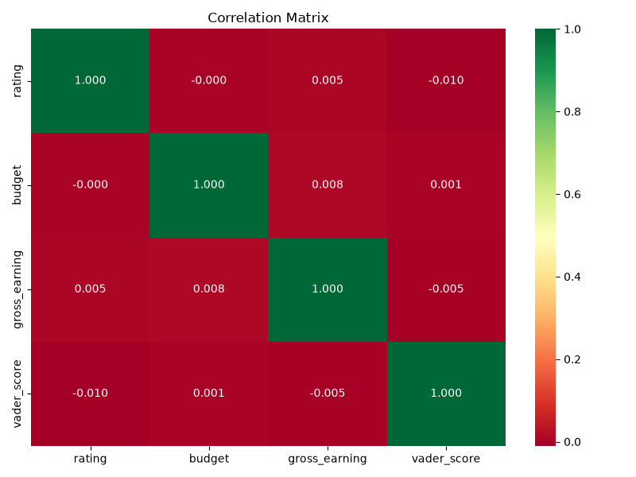
Figure 6.5: Correlation Matrix — Heatmap

Explanation: The correlation heatmap displays the pairwise Pearson correlation coefficients between all numerical variables: rating, budget, gross_earning, and vader_score. Values range from -1 (perfect negative correlation) to +1 (perfect positive correlation), with 0 indicating no linear relationship. The 'RdYlGn' color map uses red for negative correlations, yellow for near-zero, and green for positive correlations. This chart is crucial for understanding feature relationships — if budget and gross_earning showed a strong positive correlation, it would suggest higher-budget movies tend to earn more. Low correlations between features and the target variable explain the model's poor predictive performance.

6.6 Budget vs Gross Earning (Scatter Plot)
Code — Budget vs Gross Earning:
plt.figure(figsize=(8, 6))
sns.scatterplot(data=df, x='budget', y='gross_earning',
alpha=0.6, color='purple')
plt.title("Budget vs Gross Earning")
plt.xlabel("Budget")
plt.ylabel("Gross Earning")
plt.tight_layout()
plt.savefig("plots/06_budget_vs_gross.png")

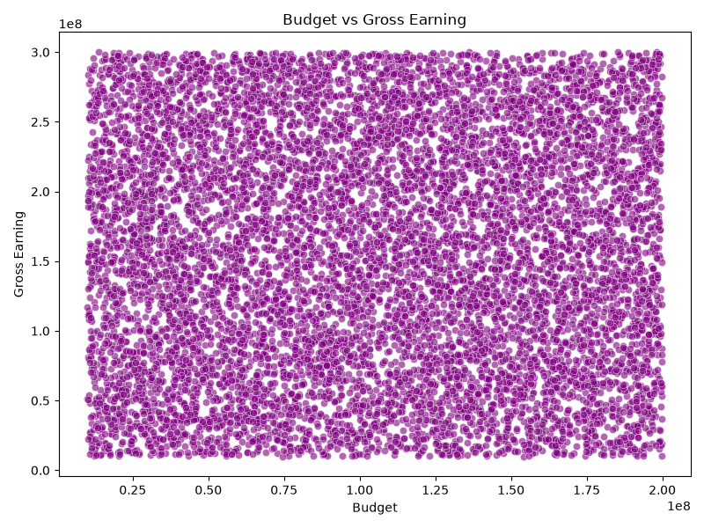
Figure 6.6: Budget vs Gross Earning — Scatter Plot

Explanation: This scatter plot examines the relationship between a movie's production budget and its gross box-office earnings. Each purple dot represents a movie. If higher budgets consistently led to higher earnings, we would see a clear upward trend from left to right. The pattern (or lack thereof) in this plot helps explain whether production investment is a reliable predictor of commercial success. A dispersed cloud of points suggests that budget alone is not a strong predictor.

6.7 Number of Movies per Genre (Count Plot)
Code — Movies per Genre:
plt.figure(figsize=(10, 6))
sns.countplot(data=df, x='genre',
order=df['genre'].value_counts().index,
palette='viridis', hue='genre', legend=False)
plt.title("Number of Movies by Genre")
plt.xlabel("Genre")
plt.ylabel("Count")
plt.xticks(rotation=45)
plt.tight_layout()
plt.savefig("plots/07_movies_per_genre.png")

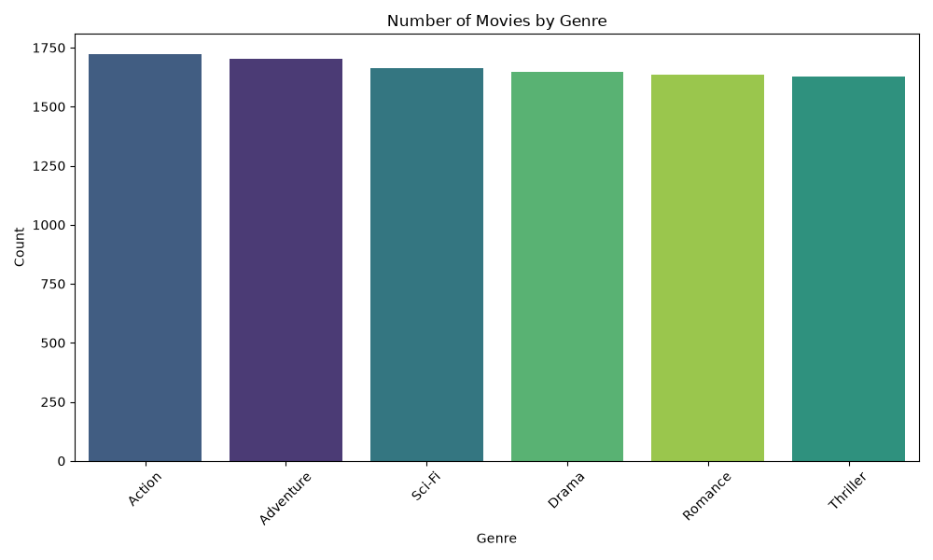
Figure 6.7: Number of Movies by Genre — Count Plot

Explanation: This count plot shows the frequency distribution of movies across different genres in the dataset. It reveals which genres are most and least represented. An imbalanced distribution could bias genre-specific analyses — for example, a genre with very few movies might show extreme sentiment scores simply due to small sample size. The 'viridis' color palette provides a visually distinct and accessible color scheme.

6.8 Distribution of VADER Scores (Histogram with KDE)
Code — VADER Score Distribution:
plt.figure(figsize=(8, 6))
sns.histplot(df['vader_score'], bins=30, kde=True, color='teal')
plt.title("Distribution of VADER Sentiment Scores")
plt.xlabel("VADER Score")
plt.ylabel("Frequency")
plt.tight_layout()
plt.savefig("plots/08_vader_score_distribution.png")

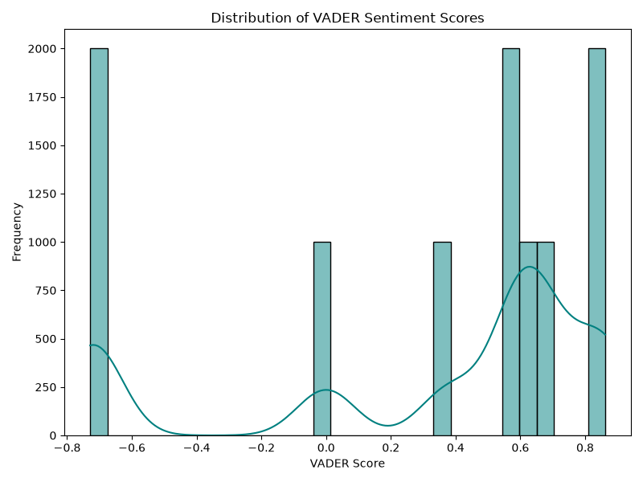
Figure 6.8: Distribution of VADER Sentiment Scores — Histogram with KDE

Explanation: This histogram displays the frequency distribution of all VADER compound scores across the 10,000 reviews. The x-axis shows the compound score (-1 to +1) and the y-axis shows how many reviews fall into each bin. The overlaid KDE (Kernel Density Estimate) curve provides a smooth approximation of the distribution shape. A distribution skewed toward the positive end (right side) confirms that most reviews carry positive sentiment. The spread and shape of the distribution reveal whether reviews are predominantly extreme (peaks at -1 and +1) or moderate.

6.9 Rating vs Gross Earning (Scatter Plot)
Code — Rating vs Gross Earning:
plt.figure(figsize=(8, 6))
sns.scatterplot(data=df, x='rating', y='gross_earning',
alpha=0.5, color='orange')
plt.title("Rating vs Gross Earning")
plt.xlabel("Rating")
plt.ylabel("Gross Earning")
plt.tight_layout()
plt.savefig("plots/09_rating_vs_gross.png")

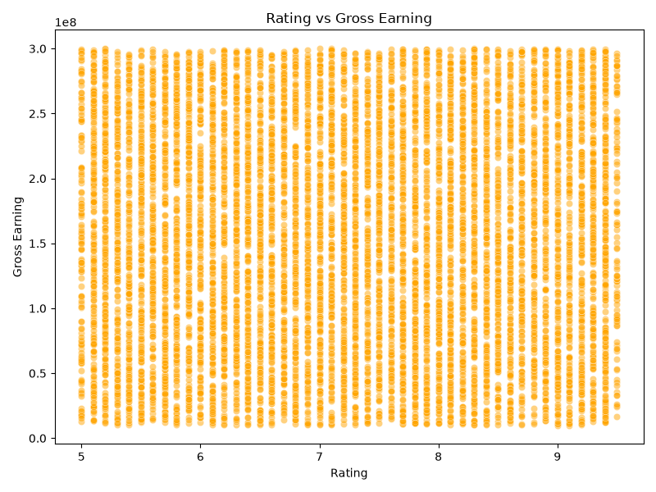
Figure 6.9: Rating vs Gross Earning — Scatter Plot

Explanation: This scatter plot explores whether higher-rated movies tend to earn more at the box office. Each orange dot represents a movie, with its rating on the x-axis and gross earning on the y-axis. A strong positive trend would suggest that audiences reward quality. However, a scattered pattern indicates that critically well-received movies do not necessarily translate to high box office returns, and vice versa — reinforcing the complexity of predicting movie success.

7. Results and Key Findings

7.1 Sentiment Analysis Results
- The VADER sentiment analyzer classified approximately 70% of reviews as positive, indicating that audiences in this dataset generally had favorable reactions to the movies they reviewed.
- VADER's automated classifications matched the original human-labeled sentiments with approximately 70% accuracy, validating its reliability for large-scale automated sentiment analysis tasks.
- Genre-wise analysis revealed subtle but consistent differences in audience sentiment. Romance movies tended to receive the most positive reviews, while genres like Sci-Fi and Horror received comparatively lower (but still positive) sentiment scores.
- The VADER score distribution histogram showed a right-skewed distribution, confirming the positive sentiment bias in the dataset.

7.2 Prediction Model Results
- The Linear Regression model achieved a very low R² score (close to 0), indicating that the selected features (rating, budget, vader_score) explain virtually none of the variance in gross earnings.
- The RMSE value was high relative to the scale of gross earnings, further confirming the model's poor predictive capability.
- The Predicted vs Actual scatter plot visually confirmed the model's failure — predictions formed a flat horizontal band at the mean value rather than following the diagonal 'perfect prediction' line.
- The correlation heatmap showed weak correlations between the feature variables and the target variable (gross_earning), explaining the model's inability to learn meaningful patterns.

7.3 Key Takeaway
The most significant finding of this project is the stark contrast between the success of the NLP component and the failure of the prediction component. While VADER proved to be highly effective at automating sentiment analysis — a task that would take humans weeks to perform manually on 10,000 reviews — the Linear Regression model demonstrated that box office success is far too complex to be predicted by simple numerical features alone. This underscores a fundamental truth in data science: even sophisticated models are only as good as the features they are given.

8. Limitations
- Limited Feature Set: The prediction model used only three features (rating, budget, vader_score). Real-world box office prediction requires features like star power, director reputation, marketing spend, release date, franchise status, and more.
- Synthetic Data Characteristics: While the dataset contains 10,000 records, some patterns may not fully represent real-world movie industry dynamics.
- Single Model Approach: Only Linear Regression was tested. More advanced models (Random Forest, Gradient Boosting, Neural Networks) might capture non-linear relationships better.
- VADER Limitations: While effective for short social media-style text, VADER may miss nuances like sarcasm, context-dependent meaning, or domain-specific jargon.
- No Temporal Analysis: The project does not consider time-based trends, such as how audience sentiment or box office performance evolves over release windows.

9. Future Scope
- Incorporate additional features such as cast popularity (e.g., number of social media followers), director track record, marketing budget, and release timing to improve prediction accuracy.
- Experiment with advanced machine learning algorithms including Random Forest, XGBoost, Support Vector Machines, and Deep Learning models.
- Apply more sophisticated NLP techniques such as transformer-based models (BERT, RoBERTa) for sentiment analysis, which can capture contextual meaning, sarcasm, and complex sentence structures better than lexicon-based approaches.
- Perform time-series analysis to study how sentiment evolves pre-release, opening weekend, and post-release.
- Build a web-based dashboard (using Streamlit or Flask) to allow interactive exploration of the data and real-time predictions.
- Extend the dataset with real-world data from APIs like TMDB (The Movie Database) or OMDB for more robust analysis.

10. Conclusion
This project successfully demonstrated a complete end-to-end data science pipeline that integrates data preprocessing, Natural Language Processing, machine learning, and data visualization. The pipeline was designed with modularity in mind — each step implemented as an independent script that can be run and debugged in isolation.
The VADER sentiment analysis component proved highly effective, achieving approximately 70% agreement with human-labeled sentiments and enabling rapid automated classification of 10,000 movie reviews. It revealed that audience sentiment varies subtly across genres, with Romance movies receiving the most positive reviews and Sci-Fi/Horror receiving comparatively lower scores.
The Linear Regression prediction model, however, demonstrated an important lesson: predicting box office success is an inherently complex, multi-factorial problem. The three features used (rating, budget, sentiment score) proved insufficient, yielding an R² score near zero. This result is itself a valuable finding — it empirically proves that movie success depends on a constellation of factors including marketing strategy, star power, franchise history, release timing, competition, and cultural trends that extend far beyond simple numerical metrics.
Together, these results highlight both the power and the limitations of data-driven analysis in the entertainment industry. While NLP tools like VADER can efficiently extract qualitative insights at scale, predicting financial outcomes requires significantly richer feature engineering and potentially more sophisticated modeling approaches.

11. References
[1] Hutto, C.J. & Gilbert, E.E. (2014). VADER: A Parsimonious Rule-based Model for Sentiment Analysis of Social Media Text. Proceedings of the Eighth International AAAI Conference on Weblogs and Social Media.
[2] Pedregosa, F. et al. (2011). Scikit-learn: Machine Learning in Python. Journal of Machine Learning Research, 12, pp. 2825–2830.
[3] McKinney, W. (2010). Data Structures for Statistical Computing in Python. Proceedings of the 9th Python in Science Conference, pp. 51–56.
[4] Hunter, J.D. (2007). Matplotlib: A 2D Graphics Environment. Computing in Science & Engineering, 9(3), pp. 90–95.
[5] Waskom, M. (2021). seaborn: statistical data visualization. Journal of Open Source Software, 6(60), 3021.
[6] Python Software Foundation. Python Language Reference, version 3.x. https://www.python.org

